Advanced Living Systems
Invertebrate Biodiversity and Classification

Time: 25 minutes
Group Size: 10-15 students
Grade Levels: 6th-8th grade
Location: At Sea

OVERVIEW OF ACTIVITY

Based on changing environments, animals have evolved to for a great biodiversity. To organize this large number of plants and animals, the Biological Classification System allows scientists to group organisms based on how closely they are related.
Students will learn the characteristics of marine invertebrate phylums that are represented in our tank farm. In this activity, students will use a field guide to locate four assigned invertebrate animals. Using their observation skills, they will list some of the general characteristics found in these animals. The students will then be supplied with a general classification sheet listing common characteristics for each represented invertebrate phylum. Using this information, they will identify what phylum their assigned animals are in and why.

PERFORMANCE OBJECTIVES

Students will be able to:
- List at least three characteristics of each animal and identify two animals which might be related.
- Place their assigned animals in the correct phylum and explain their decision.

CHALLENGE

Work in groups to find the animals listed on the activity sheet in the tank farm. Observe them, identify their characteristics, and properly determine their phylum.

MATERIALS

- (4) data sheets on clip boards
- (4) field guides
- (4) vis-a-vis pens
- (4) Phylum characteristics sheets
- Biological classification system sheet (kingdom, phylum…)

ADVANCE PREPARATION

- Set up folded table in tank farm.
- Set out data sheets on clipboards, field guides, vis a vis pens, and phylum characteristic sheets.
- Make sure all animals on the lists are still located in tanks. If they are not all available get out another list that has all the animals or change the animal on the list with a vis a vis pen.
- When possible take the animal information sign boards off the tank racks. We want the students to observe the animals and use field guides not read signs.

TEACHING TIPS
    - Tank Farm Rules: Explain how some behaviors stress the animals. Because of this, they need to keep their hands off the tanks and out of the water. They also need to move slowly around the schooling fish. Set boundaries: stay out of the jelly area, stay in this room.
    - Observation skills are important. Try to help facilitate their observations to general characteristics rather than specific information used for Specie identification.

PROCEDURE

Engage (2 minutes):
- Scientists organize all plants and animals into a classification system. Have you ever heard of this system? Show them the biological classification system: Kingdom, phylum, class, order family, genus, species. This system starts with general characteristics that animals have in common then gets more specific as you go down the list.
- Instructor note: DO NOT tell the students the invertebrate phylums in the introduction. This is their challenge. Do not let them see the phylum cards until after their observation.

Explore (17 minutes):
- Divide the group into 4 teams, hand out data sheets, set boundaries and rules and get started.
- Give the students time to complete their Data Cards while you walk around and facilitate.
- When a group has finished their observations give them the sheet with the phylum characteristics listed.
- Have them use this sheet to decide what phylum their animals are in.

Explain and Extend (4 minutes):
- What is one animal you found and what characteristics did it have? (Answer will vary depending on animals they had on their list.)

- What phylum were your animals in and why? (Answer will vary depending on animals they had on their list.)

- What animals on your list were related and what characteristics did they have in common? (Answer will vary depending on animals they had on their list.)

- Did any of your observed characteristics match the phylum characteristics? (Answers will vary depending on student experience.

- Did you notice more phylum characteristics or species-specific characteristics? Why was this? (Answers will vary depending on student experience.)

- Why is it important to be able to identify an animal’s phylum? (The first step in identifying a species is to know the general type of animal it is, starting with phylum and working down the classification system to species. Knowing the phylum will let you know the animals it is related to and therefore possibly infer other types of information.)

- Do you know how or why science organizes all animals and plants in the biological classification system? (One of the functions of comparative biology is to describe the patterns inherent in living systems and to explain those patterns that have resulted from evolutionary processes.)

Evaluate (2 minutes):
  - What did you like about conducting the classification study? Why? (Answers will vary depending on student experience. Elicit responses that deal with content, teamwork, and careers.)

  - What did you dislike about conducting the classification study? Why? (Answers will vary depending on student experience. Elicit responses that deal with content, teamwork, and careers.)

  - What was the most difficult aspect of conducting the classification study? (Answers will vary depending on student experience. Elicit responses that deal with content, teamwork, and careers.)

  - How did you overcome the difficulty? (Answers will vary depending on student experience.)

RECOMMENDED ASSESSMENT STRATEGY
Observe the students as they observe the animals making sure they understand the task, providing feedback as necessary. Use the discussion questions to check for student understanding.

ACTIVITY RESOURCES

General Characteristics of Invertebrate Phylum’s Present in OI Tanks

Phylum Mollusca (soft-bodied)
- muscular foot, modified in various groups
- mantle that often secretes a calcareous shell or a stiffening structure
- Hard mouth parts called radula used as a rasp

Phylum Arthropoda (jointed legs)
- Exoskeleton
- Jointed legs
- Segmented

Phylum Echinodermata (spiny skin)
- 5-part Radial symmetry (in adult form)
- visible spines
- Calcified endoskeleton
- Water vascular system
- tube feet

Phylum Annelida (Segmented worms)
- External and internal division of the body into segments

Phylum Cnidaria (hollow gut)
- Radial symmetry
- Central digestive cavity
- Single opening surrounded by tentacles

The tentacles contain nematocysts or stinging capsules
- Two body forms, one fixed, non-mobile (polyp); one free- swimming (medusa)

Phylum Porifera (pore-bearing)
- Sessile (not moving)
- All aquatic animal
- Bodies perforated with a network of canals that open to the surrounding water through pores

BACKGROUND INFO

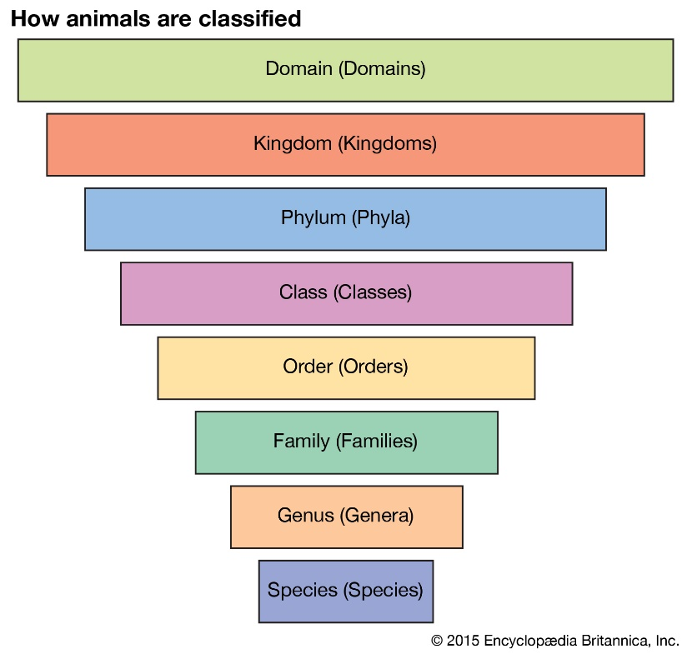
Comparative biology is the science of the diversity of life. One of the functions of comparative biology is to describe the patterns inherent in living systems and to explain those patterns that have resulted from evolutionary processes. Organisms can be described using similarities and differences in their characteristics. This organizational scheme is called biological classification.

Biological Classification Scheme
Kingdom
Phylum
Class
Order
Family
Genus
Species
*Sub and super groups not included
